1. Write a C++ program to perform the following operations :
a) Create a Singly linked list of elements.
b) Search for a given element in the above list.
c) Delete an element from the above Singly linked list
d) Display the contents of the list
#include<iostream.h>
#include<conio.h>
struct node
{
int data ;
node *link ;
};
class singlelink
{
private :
node * head;
public :
node *head ;
public :
single link ()
{
head=new node;
head->data =null;
head->link=null;
void insert-front(int);
void insert-last(int);
void delete-front();
void delete-end();
void display();
void empty();
};
void singlelink:insert front (int n)
{
node*temp;
temp=new node;
temp->data=n;
temp->link=null;
if(head->data==null&&head->link==null)
head=temp;
else
{
temp->link=head;
head=temp;
}
}
void singlelink::insert last (int m)
{
node *temp=new node;
temp->data=m;
temp->link=null;
if(head->data ==null &&head->lint==null)
head=temp;
node(=*prev;
prev=head;
while(prev->link!=null)
{
prev=prev->link;
}
prev->link=temp;
}
void singlelink :: insert -mid(int pos,int n)
{
node *temp=new node;
temp->data=n;
temp->link=null;
if (head ->data ==null&&head ->link =null)
{
cout<<"ur list is empty so possible to insert at first position:";
head=temp;
}
else
{
int i=1;
node *temp;
node *next=head;
while((<=(pos-1))
{
temp1=next->link;
i++;
}
temp->link=next;
temp1->link =temp;
}}
void single link :: delte front ()
{
node *temp;
temp=head;
if(head->data ==null && head->link==null)
cout<<"your list is empty ";
else
{
node *t;
t=head;
temp=temp->link;
head=temp;
delete t;
}
}
void singler link ::delete-end()
{
node *temp;
temp=head;
if (head ->datA ==null && head->link==null)
cout<<"your list is empty";
else
{
node*temp1=head;
while(temp1->link!=null)
{
temp1=temp1->link;
}
delete temp;
}
void singalelink::delete val (int n)
{
node *temp;
temp=head;
if(head->data==NULL && head->link== null)
cout<<"your list is empty";
else
{
node *prev=head;
node *temp1=head;
while(temp1->data!=m)
{
prev=temp1;
temp1=temp->link;
}
prev->link=temp->link;
delete temp1;
}}
void single link::search(int s)
{
if (head->data==null && head->link==null)
cout<<"your list is empty";
else
{
int i=0;
node *temp1=head;
while(temp1->link!=null)
{
if(temp1->data==S)
{
i=1;
cout<<"found";
break;
}
else
temp=temp->link;
}
else
temp=temp->link;
}
if(i==0)
cout<<"not found ";
}
}
void singlink == empty()
{
node *temp;
if (head ->data==null && head->link==null)
cout<<"list is not empty ";
}
void singelink :: disp()
{
node *temp;
temp=head;
if head->data==null && temp->link==null)
cout<<"your list is empty ";
else
{
while (temp->link!=null)
{
cout << temp->data<<"->";
temp=temp->link;
}
cout << temp->data;
}
}
void single ::~single link()
{
node *temp;
temp=head;
if temp->data==null&& temp->link==null)
delete temp;
else
{
while (temp!=null)
{
t=temp;
temp=temp->link;
delete t;
}
}
}
void main ()
{
int ch;
cout <<"enter your choice ...";
cin>>ch;
single link sl;
switch (ch)
{
case 1:cout <<"insert vthe front values ";
int a[10],i;
for (i=0;i<=3;i++)
{
cin >>a[i];
sl.display ();
break;

case 2: cout <<"inserting values out last :";
int b[10],5;
for (j=0;j<=3;j++)
{
cin >> b[j];
sl.insert last (b[j]);
}
sl.disp();
break ;

case 3: cout <<"delete value at front ";
sl.insert front [5];
sl.insert front[7];
sl.disp();
sl.delete front ();
sl.disp();
break;

case4 :cout<<"delete value at end ";
sl.insert -front (100);
sl.insert-front (200);
sl.disp();
break;
case 6 :cout <<"terminate the program";
break;
getch ();
}

OUT PUT :
save : single lik.cpp
ctrl+f9
enter your chocies
1.insert front
2.insert last
3.delete front
4.delete end
5.terminate program
insert the front values
10 20 30 40
40
30
20
10
enter your choice:5
30
20
10
enter your choice :6
terminating program.

2. Write a C++ program to perform the following operations:
a) Create a doubly linked list of elements.
b) Delete an element from the above doubly linked list
c) Display the contents of the list.
#include<iostream>
#include<cstdio>
#include<cstdlib>
using namespace std;
struct node
{
int info;
struct node *next;
struct node *prev;
}*start;
class double_llist
{
public:
void create_list(int value);
void add_begin(int value);
void add_after(int value, int position);
void delete_element(int value);
void search_element(int value);
void display_dlist();
void count();
void reverse();
double_llist()
{
start = NULL;
}
};
int main()
{
int choice, element, position;
double_llist dl;
while (1)
{
cout<<endl<<"----------------------------"<<endl;
cout<<endl<<"Operations on Doubly linked list"<<endl;
cout<<endl<<"----------------------------"<<endl;
cout<<"1.Create Node"<<endl;
cout<<"2.Add at begining"<<endl;
cout<<"3.Add after position"<<endl;
cout<<"4.Delete"<<endl;
cout<<"5.Display"<<endl;
cout<<"6.Count"<<endl;
cout<<"7.Reverse"<<endl;
cout<<"8.Quit"<<endl;
cout<<"Enter your choice : ";
cin>>choice;
switch ( choice )
{
case 1:
cout<<"Enter the element: ";
cin>>element;
dl.create_list(element);
cout<<endl;
break;
case 2:
cout<<"Enter the element: ";
cin>>element;
dl.add_begin(element);
cout<<endl;
break;
case 3:
cout<<"Enter the element: ";
cin>>element;
cout<<"Insert Element after postion: ";
cin>>position;
dl.add_after(element, position);
cout<<endl;
break;
case 4:
if (start == NULL)
{
cout<<"List empty,nothing to delete"<<endl;
break;
}
cout<<"Enter the element for deletion: ";
cin>>element;
dl.delete_element(element);
cout<<endl;
break;
case 5:
dl.display_dlist();
cout<<endl;
break;
case 6:
exit(1);
default:
cout<<"Wrong choice"<<endl;
}
}
return 0;
}
void double_llist::create_list(int value)
{
struct node *s, *temp;
temp = new(struct node);
temp->info = value;
temp->next = NULL;
if (start == NULL)
{
temp->prev = NULL;
start = temp;
}
else
{
s = start;
while (s->next != NULL)
s = s->next;
s->next = temp;
temp->prev = s;
}
}
void double_llist::add_begin(int value)
{
if (start == NULL)
{
cout<<"First Create the list."<<endl;
return;
}
struct node *temp;
temp = new(struct node);
temp->prev = NULL;
temp->info = value;
temp->next = start;
start->prev = temp;
start = temp;
cout<<"Element Inserted"<<endl;
}
void double_llist::add_after(int value, int pos)
{
if (start == NULL)
{
cout<<"First Create the list."<<endl;
return;
}
struct node *tmp, *q;
int i;
q = start;
for (i = 0;i < pos - 1;i++)
{
q = q->next;
if (q == NULL)
{
cout<<"There are less than ";
cout<<pos<<" elements."<<endl;
return;
}
}
tmp = new(struct node);
tmp->info = value;
if (q->next == NULL)
{
q->next = tmp;
tmp->next = NULL;
tmp->prev = q;
}
else
{
tmp->next = q->next;
tmp->next->prev = tmp;
q->next = tmp;
tmp->prev = q;
}
cout<<"Element Inserted"<<endl;
}
void double_llist::delete_element(int value)
{
struct node *tmp, *q;
if (start->info == value)
{
tmp = start;
start = start->next;
start->prev = NULL;
cout<<"Element Deleted"<<endl;
free(tmp);
return;
}
q = start;
while (q->next->next != NULL)
{
if (q->next->info == value)
{
tmp = q->next;
q->next = tmp->next;
tmp->next->prev = q;
cout<<"Element Deleted"<<endl;
free(tmp);
return;
}
q = q->next;
}
if (q->next->info == value)
{
tmp = q->next;
free(tmp);
q->next = NULL;
cout<<"Element Deleted"<<endl;
return;
}
cout<<"Element "<<value<<" not found"<<endl;
}
void double_llist::display_dlist()
{
struct node *q;
if (start == NULL)
{
cout<<"List empty,nothing to display"<<endl;
return;
}
q = start;
cout<<"The Doubly Link List is :"<<endl;
while (q != NULL)
{
cout<<q->info<<" <-> ";
q = q->next;
}
cout<<"NULL"<<endl;
}

---------------------------------
Operations on Doubly linked list
---------------------------------

1.Create Node
2.Add at begining
3.Add after
4.Delete
5.Display
6.Quit
Enter your choice : 2
Enter the element: 100
First Create the list.

---------------------------------
Operations on Doubly linked list
---------------------------------

1.Create Node
2.Add at begining
3.Add after
4.Delete
5.Display
6.Quit
Enter your choice : 3
Enter the element: 200
Insert Element after postion: 1
First Create the list.

---------------------------------
Operations on Doubly linked list
---------------------------------

1.Create Node
2.Add at begining
3.Add after
4.Delete
5.Display
6.Quit
Enter your choice : 4
List empty,nothing to delete

--------------------------------
Operations on Doubly linked list
---------------------------------

1.Create Node
2.Add at begining
3.Add after
4.Delete
5.Display
6.Quit
Enter your choice : 5
List empty,nothing to display
---------------------------------
Operations on Doubly linked list
---------------------------------
1.Create Node
2.Add at begining
3.Add after
4.Delete
5.Display
6.Quit
Enter your choice : 1
Enter the element: 100
---------------------------------
Operations on Doubly linked list
---------------------------------
1.Create Node
2.Add at begining
3.Add after
4.Delete
5.Display
6.Quit
Enter your choice : 5
The Doubly Link List is :
100 <-> NULL
----------------------------------
Operations on Doubly linked list
---------------------------------
1.Create Node
2.Add at begining
3.Add after
4.Delete
5.Display
6.Quit
Enter your choice : 2
Enter the element: 200
Element Inserted
---------------------------------
Operations on Doubly linked list
---------------------------------
1.Create Node
2.Add at begining
3.Add after
4.Delete
5.Display
6.Quit
Enter your choice : 5
The Doubly Link List is :
200 <-> 100 <-> NULL

---------------------------------
Operations on Doubly linked list
---------------------------------

1.Create Node
2.Add at begining
3.Add after
4.Delete
5.Display
6.Quit
Enter your choice : 3
Enter the element: 50
Insert Element after postion: 2
Element Inserted

--------------------------------

Operations on Doubly linked list

---------------------------------

1.Create Node
2.Add at begining
3.Add after
4.Delete
5.Display
6.Quit
Enter your choice : 5
The Doubly Link List is :
200 <-> 100 <-> 50 <-> NULL

---------------------------------
Operations on Doubly linked list
---------------------------------
1.Create Node
2.Add at begining
3.Add after
4.Delete
5.Display
6.Quit
Enter your choice : 3
Enter the element: 150
Insert Element after postion: 3
Element Inserted
---------------------------------
Operations on Doubly linked list
---------------------------------
1.Create Node
2.Add at begining
3.Add after
4.Delete
5.Display
6.Quit
Enter your choice : 5
The Doubly Link List is :
200 <-> 100 <-> 50 <-> 150 <-> NULL
---------------------------------
Operations on Doubly linked list
---------------------------------
1.Create Node
2.Add at begining
3.Add after
4.Delete
5.Display
6.Quit
Enter your choice : 6
Number of elements are: 4
---------------------------------
Operations on Doubly linked list
---------------------------------
1.Create Node
2.Add at begining
3.Add after
4.Delete
5.Display
6.Quit
Enter your choice : 4
Enter the element for deletion: 50
Element Deleted
---------------------------------
Operations on Doubly linked list
---------------------------------
1.Create Node
2.Add at begining
3.Add after
4.Delete
5.Display
6.Quit
Enter your choice : 5
The Doubly Link List is :
200 <-> 100 <-> 150 <-> NULL

3.Write C++ programs to implement the following using an array
a) stack with ADT in array
#include<iostream>
#include<conio.h>
#include<stdlib.h>
using namespace std;
class stack
{
int stk[5];
int top;
public:
stack()
{
top=-1;
}
void push(int x)
{
if(top > 4)
{
cout <<"stack over flow";
return;
}
stk[++top]=x;
cout <<"inserted" <<x;
}
void pop()
{
if(top <0)
{
cout <<"stack under flow";
return;
}
cout <<"deleted" <<stk[top--];
}
void display()
{
if(top<0)
{
cout <<" stack empty";
return;
}
for(int i=top;i>=0;i--)
cout <<stk[i] <<" ";
}};
main()
{
int ch;
stack st;
while(1)
{
cout <<"\n1.push 2.pop 3.display 4.exit\nEnter ur choice";
cin >> ch;
switch(ch)
{
case 1: cout <<"enter the element";
cin >> ch;
st.push(ch);
break;
case 2: st.pop(); break;
case 3: st.display();break;
case 4: exit(0);
}
}
return (0);
}

Input/output
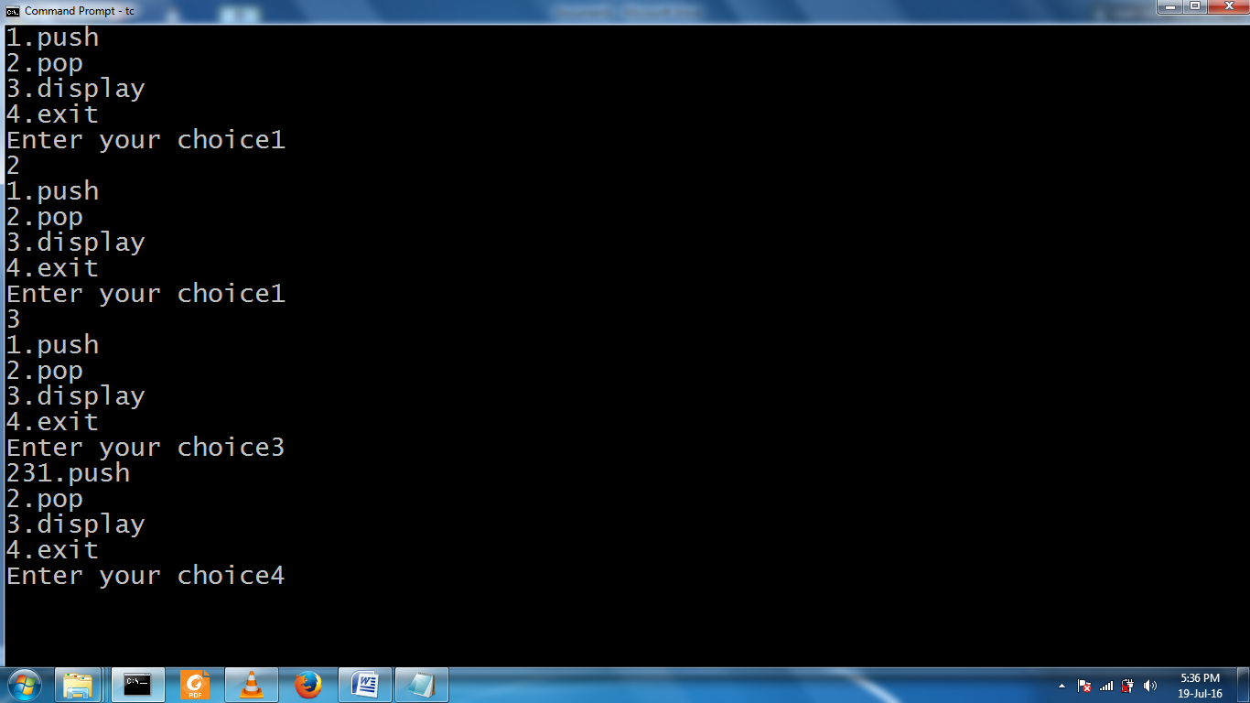

b.) Queue ADT in array
#include<iostream.h>
#include<conio.h>
#include<stdlib.h>
using namespace std;
class queue
{
int queue1[5];
int rear,front;
public:
queue()
{
rear=-1;
front=-1;
}
void insert(int x)
{
if(rear > 4)
{
cout <<"queue over flow";
front=rear=-1;
return;
}
queue1[++rear]=x;
cout <<"inserted" <<x;
}
void delet()
{
if(front==rear)
{
cout <<"queue under flow";
return;
}
cout <<"deleted" <<queue1[++front];
}
void display()
{
if(rear==front)
{
cout <<" queue empty";
return;
}
for(int i=front+1;i<=rear;i++)
cout <<queue1[i]<<" ";
}
};
main()
{
int ch;
queue qu;
while(1)
{
cout <<"\n1.insert 2.delet 3.display 4.exit\nEnter ur choice";
cin >> ch;
switch(ch)
{
case 1: cout <<"enter the element";
cin >> ch;
qu.insert(ch);
break;
case 2: qu.delet(); break;
case 3: qu.display();break;
case 4: exit(0);
}
}
return (0);
}

Input/output
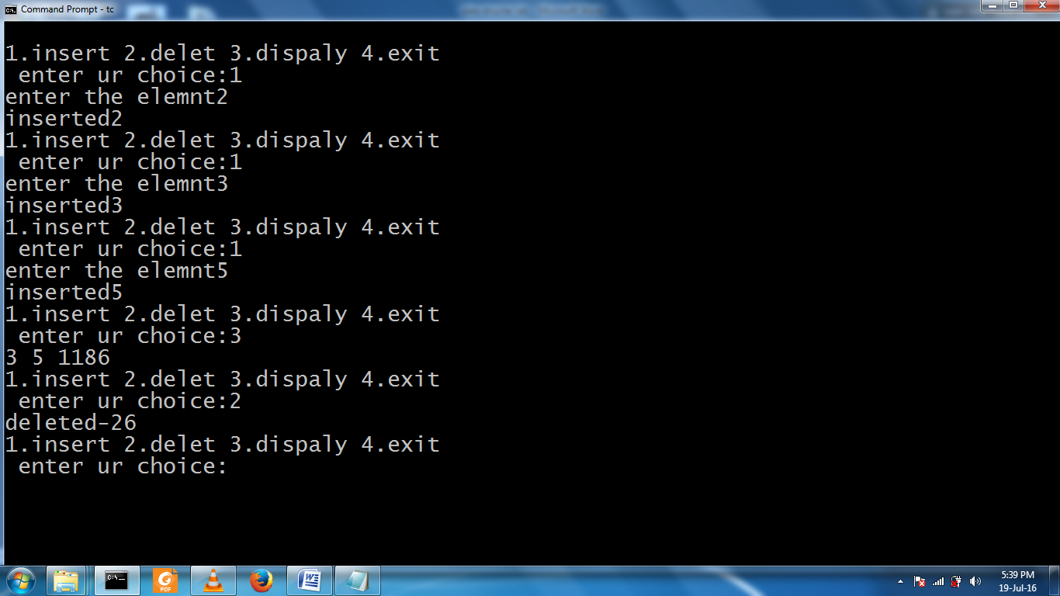

4.Write C++ programs to implement the following using a singly linked list.
a) linked list using stack adt
#include<iostream>
#include<conio.h>
#include<stdlib.h>
using namespace std;
class node
{
public:
class node *next;
int data;
};
class stack : public node
{
node *head;
int tos;
public:
stack()
{
tos=-1;
}
void push(int x)
{
if (tos < 0 )
{
head =new node;
head->next=NULL;
head->data=x;
tos ++;
}
else
{
node *temp,*temp1;
temp=head;
if(tos >= 4)
{
cout <<"stack over flow";
return;
}
tos++;
while(temp->next != NULL)
temp=temp->next;
temp1=new node;
temp->next=temp1;
temp1->next=NULL;
temp1->data=x;
}
}
void display()
{
node *temp;
temp=head;
if (tos < 0)
{
cout <<" stack under flow";
return;
}
while(temp != NULL)
{
cout <<temp->data<< " ";
temp=temp->next;
}
}
void pop()
{
node *temp;
temp=head;
if( tos < 0 )
{
cout <<"stack under flow";
return;
}
tos--;
while(temp->next->next!=NULL)
{
temp=temp->next;
}
temp->next=NULL;
}
};
main()
{
stack s1;
int ch;
while(1)
{
cout <<"\n1.PUSH\n2.POP\n3.DISPLAY\n4.EXIT\n enter ur choice:";
cin >> ch;
switch(ch)
{
case 1: cout <<"\n enter a element";
cin >> ch;
s1.push(ch);
break;
case 2: s1.pop();
break;
case 3: s1.display();
break;
case 4: exit(0);
}
}
return (0);
}

Input/ouput
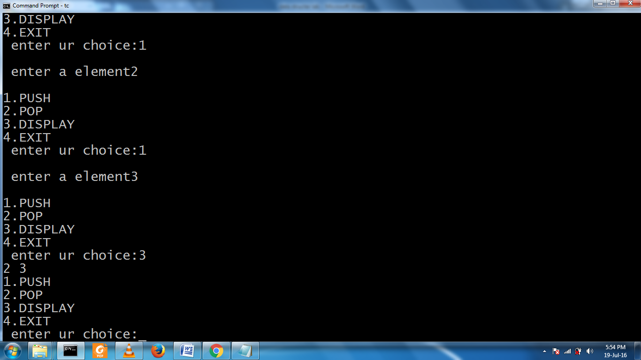

b> queue ADT link list
#include<iostream>
#include<conio.h>
#include<stdlib.h>
using namespace std;
class node
{
public:
class node *next;q
int data;
};

class queue : public node
{
node *head;
int front,rare;
public:
queue()
{
front=-1;
rare=-1;
}
void push(int x)
{
if (rare < 0 )
{
head =new node;
head->next=NULL;
head->data=x;
rare ++;
}
else
{
node *temp,*temp1;
temp=head;
if(rare >= 4)
{
cout <<"queue over flow";
return;
}
rare++;
while(temp->next != NULL)
temp=temp->next;
temp1=new node;
temp->next=temp1;
temp1->next=NULL;
temp1->data=x;
} }

void display()
{
node *temp;
temp=head;
if (rare < 0)
{
cout <<" queue under flow";
return;
}
while(temp != NULL)
{
cout <<temp->data<< " ";
temp=temp->next;
}
}
void pop()
{
node *temp;
temp=head;
if( rare < 0)
{
cout <<"queue under flow";
return;
}
if(front == rare)
{
front = rare =-1;
head=NULL;
return;
}
front++;
head=head->next;
}
};
main()
{
queue s1;
int ch;
while(1)
{
cout<<"\n1.PUSH\n2.POP\n3.DISPLAY\n4.EXIT\n enter ru choice:";
cin >> ch;
switch(ch)
{
case 1:
cout <<"\n enter a element";
cin >> ch;
s1.push(ch); break;

case 2: s1.pop();break;
case 3: s1.display();break;
case 4: exit(0);
}
}
return (0);
}

Input/output
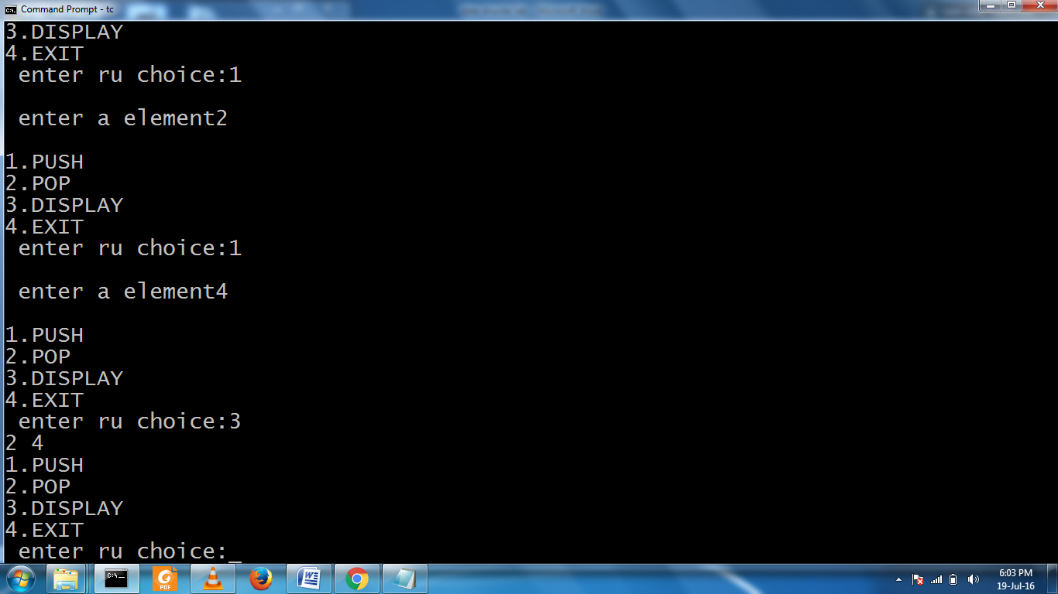

5. Write a C++ program to convert
i) a given infix expression into postfix form using stack
and ii) evaluate the Postfix expression using stack.

i) a given infix expression into postfix form using stack
#include<iostream>
#include<cstring>
#include<stack>
using namespace std;
// get weight of operators as per precedence
// higher weight given to operators with higher precedence
// for non operators, return 0
int getWeight(char ch) {
switch (ch) {
case '/':
case '*': return 2;
case '+':
case '-': return 1;
default : return 0;
}
}
// convert infix expression to postfix using a stack
void infix2postfix(char infix[], char postfix[], int size) {
stack<char> s;
int weight;
int i = 0;
int k = 0;
char ch;
// iterate over the infix expression
while (i < size) {
ch = infix[i];
if (ch == '(') {
// simply push the opening parenthesis
s.push(ch);
i++;
continue;
}
if (ch == ')') {
// if we see a closing parenthesis,
// pop of all the elements and append it to
// the postfix expression till we encounter
// a opening parenthesis
while (!s.empty() && s.top() != '(') {
postfix[k++] = s.top();
s.pop();
}
// pop off the opening parenthesis also
if (!s.empty()) {
s.pop();
}
i++;
continue;
}
weight = getWeight(ch);
if (weight == 0) {
// we saw an operand
// simply append it to postfix expression
postfix[k++] = ch;
}
else {
// we saw an operator
if (s.empty()) {
// simply push the operator onto stack if
// stack is empty
s.push(ch);
}
else {
// pop of all the operators from the stack and
// append it to the postfix expression till we
// see an operator with a lower precedence that
// the current operator
while (!s.empty() && s.top() != '(' &&
weight <= getWeight(s.top())) {
postfix[k++] = s.top();
s.pop();
}
// push the current operator onto stack
s.push(ch);
}
}
i++;
}
// pop of the remaining operators present in the stack
// and append it to postfix expression
while (!s.empty()) {
postfix[k++] = s.top();
s.pop();
}
postfix[k] = 0; // null terminate the postfix expression
}
// main
int main() {
char infix[] = "A*(B+C)/D";
int size = strlen(infix);
char postfix[size];
infix2postfix(infix,postfix,size);
cout<<"\nInfix Expression :: "<<infix;
cout<<"\nPostfix Expression :: "<<postfix;
cout<<endl;
return 0;
}
Output
Infix Expression :: A*(B+C)/D
Postfix Expression :: ABC+*D/

ii) evaluate the Postfix expression using stack.
/*
* C++ Program to Evaluate an Expression using Stacks
*/
#include <iostream>
#include <conio.h>
#include <string.h>
using namespace std;
struct node
{
int data;
node *next;
}*p = NULL, *top = NULL, *save = NULL, *ptr;
void push(int x)
{
p = new node;
p->data = x;
p->next = NULL;
if (top == NULL)
{
top = p;
}
else
{
save = top;
top = p;
p->next = save;
} }
char pop()
{
if (top == NULL)
{
cout<<"underflow!!";
}
else
{
ptr = top;
top = top->next;
return(ptr->data);
delete ptr;
} }
int main()
{
char x[30];
int a, b;
cout<<"enter the balanced expression\n";
cin>>x;
for (int i = 0; i < strlen(x); i++)
{
if (x[i] >= 48 && x[i] <= 57)
push(x[i]-'0');
else if (x[i] >= 42 && x[i] <= 47)
{
a=pop();
b=pop();
switch(x[i])
{
case '+':
push(a+b);
break;
case '-':
push(a-b);
break;
case '*':
push(a*b);
break;
case '/':
push(a/b);
break;
} } }
cout<<"ans is "<<pop()<<endl;
getch();
}
Output
enter the balanced expression
567+8-/
ans is -1

6.Write C++ programs to implement the deque (double ended queue) ADT using
a)Singly linked list b) Doubly linked list c) an array.
a)Singly linked list
#include<iostream>
#include<conio.h>
#include<stdlib.h>
using namespace std;
class Node
{
public:
int info;
Node* next;
};
class List:public Node
{
Node *first,*last;
public:
List()
{
first=NULL;
last=NULL;
}
void create();
void insert();
void delet();
void display();
void search();
};
void List::create()
{
Node *temp;
temp=new Node;
int n;
cout<<"\nEnter an Element:";
cin>>n;
temp->info=n;
temp->next=NULL;
if(first==NULL)
{
first=temp;
last=first;
}
else
{
last->next=temp;
last=temp;
}
}
void List::insert()
{
Node *prev,*cur;
prev=NULL;
cur=first;
int count=1,pos,ch,n;
Node *temp=new Node;
cout<<"\nEnter an Element:";
cin>>n;
temp->info=n;
temp->next=NULL;
cout<<"\nINSERT AS\n1:FIRSTNODE\n2:LASTNODE\n3:IN BETWEEN FIRST&LAST NODES";
cout<<"\nEnter Your Choice:";
cin>>ch;
switch(ch)
{
case 1:
temp->next=first;
first=temp;
break;
case 2:
last->next=temp;
last=temp;
break;
case 3:
cout<<"\nEnter the Position to Insert:";
cin>>pos;
while(count!=pos)
{
prev=cur;
cur=cur->next;
count++;
}
if(count==pos)
{
prev->next=temp;
temp->next=cur;
}
else
cout<<"\nNot Able to Insert";
break;
}
}
void List::delet()
{
Node *prev=NULL,*cur=first;
int count=1,pos,ch;
cout<<"\nDELETE\n1:FIRSTNODE\n2:LASTNODE\n3:IN BETWEEN FIRST&LAST NODES";
cout<<"\nEnter Your Choice:";
cin>>ch;
switch(ch)
{
case 1:
if(first!=NULL)
{
cout<<"\nDeleted Element is "<<first->info;
first=first->next;
}
else
cout<<"\nNot Able to Delete";
break;
case 2:
while(cur!=last)
{
prev=cur;
cur=cur->next;
}
if(cur==last)
{
cout<<"\nDeleted Element is: "<<cur->info;
prev->next=NULL;
last=prev;
}
else
cout<<"\nNot Able to Delete";
break;
case 3:
cout<<"\nEnter the Position of Deletion:";
cin>>pos;
while(count!=pos)
{
prev=cur;
cur=cur->next;
count++;
}
if(count==pos)
{
cout<<"\nDeleted Element is: "<<cur->info;
prev->next=cur->next;
}
else
cout<<"\nNot Able to Delete";
break;
}
}
void List::display()
{
Node *temp=first;
if(temp==NULL)
{
cout<<"\nList is Empty";
}
while(temp!=NULL)
{
cout<<temp->info;
cout<<"-->";
temp=temp->next;
}
cout<<"NULL";
}
void List::search()
{
int value,pos=0;
bool flag=false;
if(first==NULL)
{
cout<<"List is Empty";
return;
}
cout<<"Enter the Value to be Searched:";
cin>>value;
Node *temp;
temp=first;
while(temp!=NULL)
{
pos++;
if(temp->info==value)
{
flag=true;
cout<<"Element"<<value<<"is Found at "<<pos<<" Position";
return;
}
temp=temp->next;
}
if(!flag)
{
cout<<"Element "<<value<<" not Found in the List";
}
}
int main()
{
List l;
int ch;
while(1)
{
cout<<"\n**** MENU ****";
cout<<"\n1:CREATE\n2:INSERT\n3:DELETE\n4:SEARCH\n5:DISPLAY\n6:EXIT\n";
cout<<"\nEnter Your Choice:";
cin>>ch;
switch(ch)
{
case 1:
l.create();
break;
case 2:
l.insert();
break;
case 3:
l.delet();
break;
case 4:
l.search();
break;
case 5:
l.display();
break;
case 6:
return 0;
}
}
return 0;
}
OUTPUT:
**** MENU ****
1:CREATE
2:INSERT
3:DELETE
4:SEARCH
5:DISPLAY
6:EXIT
Enter Your Choice:1
Enter an Element:10
**** MENU ****
1:CREATE
2:INSERT
3:DELETE
4:SEARCH
5:DISPLAY
6:EXIT
Enter Your Choice:2
Enter an Element:20
INSERT AS
1:FIRSTNODE
2:LASTNODE
3:IN BETWEEN FIRST&LAST NODES
Enter Your Choice:2
**** MENU ****
1:CREATE
2:INSERT
3:DELETE
4:SEARCH
5:DISPLAY
6:EXIT
Enter Your Choice:2
Enter an Element:30
INSERT AS
1:FIRSTNODE
2:LASTNODE
3:IN BETWEEN FIRST&LAST NODES
Enter Your Choice:1
**** MENU ****
1:CREATE
2:INSERT
3:DELETE
4:SEARCH
5:DISPLAY
6:EXIT
Enter Your Choice:5
30-->10-->20-->NULL
**** MENU ****
1:CREATE
2:INSERT
3:DELETE
4:SEARCH
5:DISPLAY
6:EXIT
Enter Your Choice:4
Enter the Value to be Searched:20
Element20is Found at 3 Position
**** MENU ****
1:CREATE
2:INSERT
3:DELETE
4:SEARCH
5:DISPLAY
6:EXIT
Enter Your Choice:4
Enter the Value to be Searched:50
Element 50 not Found in the List
**** MENU ****
1:CREATE
2:INSERT
3:DELETE
4:SEARCH
5:DISPLAY
6:EXIT
Enter Your Choice:3
DELETE
1:FIRSTNODE
2:LASTNODE
3:IN BETWEEN FIRST&LAST NODES
Enter Your Choice:3
Enter the Position of Deletion:2
Deleted Element is: 10
**** MENU ****
1:CREATE
2:INSERT
3:DELETE
4:SEARCH
5:DISPLAY
6:EXIT
Enter Your Choice:5
30-->20-->NULL
**** MENU ****
1:CREATE
2:INSERT
3:DELETE
4:SEARCH
5:DISPLAY
6:EXIT
Enter Your Choice:6

b) Doubly linked list
#include<iostream>
#include<conio.h>
#include<stdlib.h>
using namespace std;
class node
{
public:
int data;
class node *next;
class node *prev;
};
class dqueue: public node
{
node *head,*tail;
int top1,top2;
public:
dqueue()
{
top1=0;
top2=0;
head=NULL;
tail=NULL;
}
void push(int x)
{
node *temp;
int ch;
if(top1+top2 >=5)
{
cout <<"dqueue overflow";
return ;
}
if( top1+top2 == 0)
{
head = new node;
head->data=x;
head->next=NULL;
head->prev=NULL;
tail=head;
top1++;
}
else
{
cout <<" Add element 1.FIRST 2.LAST\n Enter Your Choice:";
cin >> ch;
if(ch==1)
{
top1++;
temp=new node;
temp->data=x;
temp->next=head;
temp->prev=NULL;
head->prev=temp;
head=temp;
}
else
{
top2++;
temp=new node;
temp->data=x;
temp->next=NULL;
temp->prev=tail;
tail->next=temp;
tail=temp;
}
}
}
void pop()
{
int ch;
cout <<"Delete 1.First Node 2.Last Node\n Enter Your Choice:";
cin >>ch;
if(top1 + top2 <=0)
{
cout <<"\nDqueue under flow";
return;
}
if(ch==1)
{
head=head->next;
head->prev=NULL;
top1--;
}
else
{
top2--;
tail=tail->prev;
tail->next=NULL;
}
}
void display()
{
int ch;
node *temp;
cout <<"Display From 1.STARTING 2.ENDING\n Enter Your Choice";
cin >>ch;
if(top1+top2 <=0)
{
cout <<"under flow";
return ;
}
if (ch==1)
{
temp=head;
while(temp!=NULL)
{
cout << temp->data <<" ";
temp=temp->next;
}
}
else
{
temp=tail;
while( temp!=NULL)
{
cout <<temp->data << " ";
temp=temp->prev;
}
}
}
};
main()
{
dqueue d1;
int ch;
while (1)
{
cout <<"1.INSERT 2.DELETE 3.DISPLAY 4.EXIT\n Enter Your Choice:";
cin >>ch;
switch(ch)
{
case 1:
cout <<"Enter the Element: ";
cin >> ch;
d1.push(ch);
break;
case 2:
d1.pop();
break;
case 3:
d1.display();
break;
case 4:
exit(1);
}
}
}
Output:-
1.INSERT 2.DELETE 3.DISPLAY 4.EXIT
Enter Your Choice:1
Enter the Element: 10
1.INSERT 2.DELETE 3.DISPLAY 4.EXIT
Enter ur choice:1
Enter the Element: 15
Add element 1.FIRST 2.LAST
Enter Your Choice:2
1.INSERT 2.DELETE 3.DISPLAY 4.EXIT
Enter Your Choice:3
Display From 1.STARTING 2.ENDING
Enter Your Choice:1
10 15 1.INSERT 2.DELETE 3.DISPLAY 4.EXIT
Enter Your Choice:4

c) an array
#include<iostream>
#include<conio.h>
#include<stdlib.h>
using namespace std;
class queue
{
int queue1[5];
int rear,front;
public:
queue()
{
rear=-1;
front=-1;
}
void insert(int x)
{
if(rear > 4)
{
cout <<"queue over flow";
front=rear=-1;
return;
}
queue1[++rear]=x;
cout <<"inserted" <<x;
}
void delet()
{
if(front==rear)
{
cout <<"queue under flow";
return;
}
cout <<"deleted" <<queue1[++front];
}
void display()
{
if(rear==front)
{
cout <<" queue empty";
return;
}
for(int i=front+1;i<=rear;i++)
cout <<queue1[i]<<" ";
}
};
main()
{
int ch;
queue qu;
while(1)
{
cout <<"\n1.insert 2.delet 3.display 4.exit\nEnter ur choice";
cin >> ch;
switch(ch)
{
case 1: cout <<"enter the element";
cin >> ch;
qu.insert(ch);
break;
case 2: qu.delet(); break;
case 3: qu.display();break;
case 4: exit(0);
}
}
return (0);
}

OUTPUT
1.insert 2.delet 3.display 4.exit
Enter ur choice1
enter the element21
inserted21
1.insert 2.delet 3.display 4.exit
Enter ur choice1
enter the element22
inserted22
1.insert 2.delet 3.display 4.exit
Enter ur choice1
enter the element16
inserted16
1.insert 2.delet 3.display 4.exit
Enter ur choice3
21 22 16
1.insert 2.delet 3.display 4.exit
Enter ur choice2
deleted21
1.insert 2.delet 3.display 4.exit
Enter ur choice3
22 16
1.insert 2.delet 3.display 4.exit
Enter ur choice

7. Write C++ programs that use recursive functions to traverse the given binary tree in
a) Preorder b) Inorder and c) Postorder

#include <iostream>
using namespace std;
// Node class
class Node {
int key;
Node* left;
Node* right;
public:
Node() { key=-1; left=NULL; right=NULL; };
void setKey(int aKey) { key = aKey; };
void setLeft(Node* aLeft) { left = aLeft; };
void setRight(Node* aRight) { right = aRight; };
int Key() { return key; };
Node* Left() { return left; };
Node* Right() { return right; };
};
// Tree class
class Tree {
Node* root;
public:
Tree();
~Tree();
Node* Root() { return root; };
void addNode(int key);
void inOrder(Node* n);
void preOrder(Node* n);
void postOrder(Node* n);
private:
void addNode(int key, Node* leaf);
void freeNode(Node* leaf);
};
// Constructor
Tree::Tree() {
root = NULL;
}
// Destructor
Tree::~Tree() {
freeNode(root);
}
// Free the node
void Tree::freeNode(Node* leaf)
{
if ( leaf != NULL )
{
freeNode(leaf->Left());
freeNode(leaf->Right());
delete leaf;
}
}
// Add a node
void Tree::addNode(int key) {
// No elements. Add the root
if ( root == NULL ) {
cout << "add root node ... " << key << endl;
Node* n = new Node();
n->setKey(key);
root = n;
}
else {
cout << "add other node ... " << key << endl;
addNode(key, root);
}
}
// Add a node (private)
void Tree::addNode(int key, Node* leaf) {
if ( key <= leaf->Key() ) {
if ( leaf->Left() != NULL )
addNode(key, leaf->Left());
else {
Node* n = new Node();
n->setKey(key);
leaf->setLeft(n);
}
}
else {
if ( leaf->Right() != NULL )
addNode(key, leaf->Right());
else {
Node* n = new Node();
n->setKey(key);
leaf->setRight(n);
}
}
}
// Print the tree in-order
// Traverse the left sub-tree, root, right sub-tree
void Tree::inOrder(Node* n) {
if ( n ) {
inOrder(n->Left());
cout << n->Key() << " ";
inOrder(n->Right());
}
}
// Print the tree pre-order
// Traverse the root, left sub-tree, right sub-tree
void Tree::preOrder(Node* n) {
if ( n ) {
cout << n->Key() << " ";
preOrder(n->Left());
preOrder(n->Right());
}
}
// Print the tree post-order
// Traverse left sub-tree, right sub-tree, root
void Tree::postOrder(Node* n) {
if ( n ) {
postOrder(n->Left());
postOrder(n->Right());
cout << n->Key() << " ";
}
}
// Test main program
int main() {
Tree* tree = new Tree();
tree->addNode(30);
tree->addNode(10);
tree->addNode(20);
tree->addNode(40);
tree->addNode(50);
cout << "In order traversal" << endl;
tree->inOrder(tree->Root());
cout << endl;
cout << "Pre order traversal" << endl;
tree->preOrder(tree->Root());
cout << endl;
cout << "Post order traversal" << endl;
tree->postOrder(tree->Root());
cout << endl;
delete tree;
return 0;
}
.

OUTPUT:-
add root node ... 30
add other node ... 10
add other node ... 20
add other node ... 40
add other node ... 50
In order traversal
10 20 30 40 50
Pre order traversal
30 10 20 40 50
Post order traversal
20 10 50 40 30

8.Write a C++ program to perform the following operations:
a) Construct a binary search tree of elements.
b) Search for a key element in the above binary search tree.
c) Delete an element from the above binary search tree.

#include<iostream>
#include<conio.h>
#include<stdlib.h>
using namespace std;
void insert(int,int );
void delte(int);
void display(int);
int search(int);
int search1(int,int);
int tree[40],t=1,s,x,i;
main()
{
int ch,y;
for(i=1;i<40;i++)
tree[i]=-1;
while(1)
{
cout <<"1.INSERT\n2.DELETE\n3.DISPLAY\n4.SEARCH\n5.EXIT\nEnter your choice:";
cin >> ch;
switch(ch)
{
case 1:
cout <<"enter the element to insert";
cin >> ch;
insert(1,ch);
break;
case 2:
cout <<"enter the element to delete";
cin >>x;
y=search(1);
if(y!=-1) delte(y);
else cout<<"no such element in tree";
break;
case 3:
display(1);
cout<<"\n";
for(int i=0;i<=32;i++)
cout <<i;
cout <<"\n";
break;
case 4:
cout <<"enter the element to search:";
cin >> x;
y=search(1);
if(y == -1) cout <<"no such element in tree";
else cout <<x << "is in" <<y <<"position";
break;
case 5:
exit(0);
}
}
}
void insert(int s,int ch )
{
int x;
if(t==1)
{
tree[t++]=ch;
return;
}
x=search1(s,ch);
if(tree[x]>ch)
tree[2*x]=ch;
else
tree[2*x+1]=ch;
t++;
}
void delte(int x)
{
if( tree[2*x]==-1 && tree[2*x+1]==-1)
tree[x]=-1;
else if(tree[2*x]==-1)
{ tree[x]=tree[2*x+1];
tree[2*x+1]=-1;
}
else if(tree[2*x+1]==-1)
{ tree[x]=tree[2*x];
tree[2*x]=-1;
}
else
{
tree[x]=tree[2*x];
delte(2*x);
}
t--;
}
int search(int s)
{
if(t==1)
{
cout <<"no element in tree";
return -1;
}
if(tree[s]==-1)
return tree[s];
if(tree[s]>x)
search(2*s);
else if(tree[s]<x)
search(2*s+1);
else
return s;
}

void display(int s)
{
if(t==1)
{cout <<"no element in tree:";
return;}
for(int i=1;i<40;i++)
if(tree[i]==-1)
cout <<" ";
else cout <<tree[i];
return ;
}
int search1(int s,int ch)
{
if(t==1)
{
cout <<"no element in tree";
return -1;
}
if(tree[s]==-1)
return s/2;
if(tree[s] > ch)
search1(2*s,ch);
else search1(2*s+1,ch);
}

OUTPUT:-
1.INSERT
2.DELETE
3.DISPLAY
4.SEARCH
5.EXIT
Enter your choice:3
no element in tree:
0123456789011121314151617181920212223242526272829303132
1.INSERT
2.DELETE
3.DISPLAY
4.SEARCH
5.EXIT
Enter your choice:1
Enter the element to insert 10
1.INSERT
2.DELETE
3.DISPLAY
4.SEARCH
5.EXIT
Enter your choice:4
Enter the element to search: 10
10 is in 1 position
1.INSERT
2.DELETE
3.DISPLAY
4.SEARCH
5.EXIT
Enter your choice:5

9.Write C++ programs for implementing the following Searching methods:
a) Linear Search b) Binary Search
a> linear search
#include<iostream>
using namespace std;
int main() {
cout<<"Enter The Size Of Array: ";
int size;
cin>>size;
int array[size], key,i;
// Taking Input In Array
for(int j=0;j<size;j++){
cout<<"Enter "<<j<<" Element: ";
cin>>array[j];
}
//Your Entered Array Is
for(int a=0;a<size;a++){
cout<<"array[ "<<a<<" ] = ";
cout<<array[a]<<endl;
}
cout<<"Enter Key To Search in Array";
cin>>key;
for(i=0;i<size;i++){
if(key==array[i]){
cout<<"Key Found At Index Number : "<<i<<endl;
break;
}
}
if(i != size){
cout<<"KEY FOUND at index : "<<i;
}
else{
cout<<"KEY NOT FOUND in Array ";
}
return 0;
}

Output
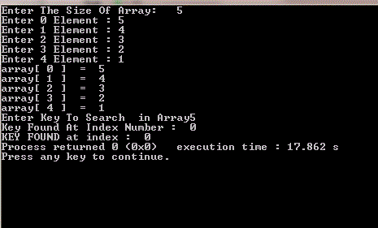

b> binary search
#include<stdio.h>
#include<iostream.h>
#include<conio.h>
void main(){
int a[10],num,n,beg,end,mid ,f=0,i;
clrscr();
cout<<"\n enter the number of elements in the array : ";
cin>>n;
cout<<"\n enter the element :";
for(i=0;i<n;i++){
cin>>a[i];
}
cout<<"\n eneter the number thst has to be searched :";
cin>>num;
beg=0;
end=n-1;
while(beg<=end){
mid=(beg+end)/2;
if(a[mid]==num){
cout<<"\n is present in the array at position ="<<num<<mid;
f=1;
break;
}
else if(a[mid]>num)
end=mid-1;
else
end=mid+1;
}
if(beg>end && f==0)
cout<<"does not exit in the array "<<num;
getch();
}
Output
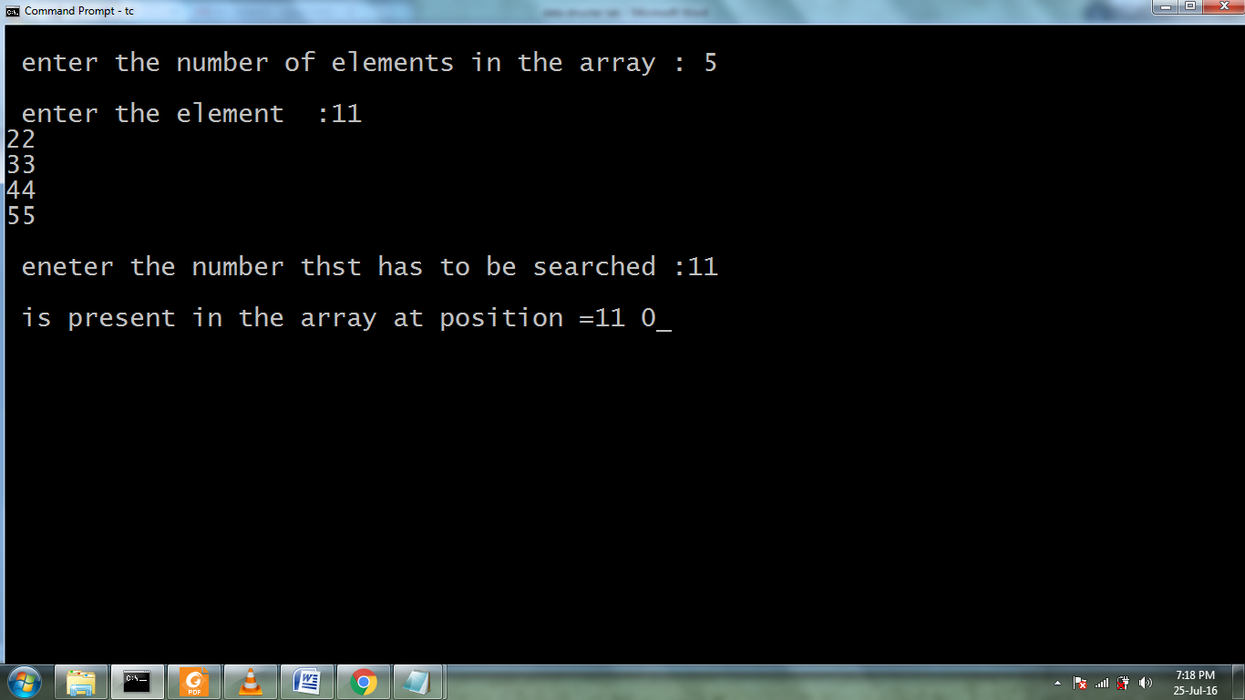

10.Write C++ programs for implementing the following sorting methods:
a) Bubble Sort b) Selection Sort c) Insertion Sort
a) Bubble Sort
#include<iostream>
using namespace std;
void main()
{
int a[50],i,j,n;
printf("Enter array elements\n");
scanf("%d",&n);
printf("Array Elements\n");
for(i=0;i<n;i++)
scanf("%d",&a[i]);
for(i=0;i<n-1;i++)
{
for(j=0;j<n-1;j++)
{
if(a[j]>a[j+1])
{
int temp;
temp=a[j];
a[j]=a[j+1];
a[j+1]=temp;
}
}
}
printf("sorted array(bubble sort)\n");
for(i=0;i<n;i++)
printf("%5d",a[i]);
}

Output
Enter array elements 5
99 55 77 22 11 44
Array Elements
99 55 77 22 11 44
sorted array(bubble sort)
11 22 44 55 77 99

b) Selection Sort
#include<iostream>
using namespace std;
int main()
{
int i,j,n,loc,temp,min,a[30];
cout<<"Enter the number of elements:";
cin>>n;
cout<<"\nEnter the elements\n";

for(i=0;i<n;i++)
{
cin>>a[i];
}
for(i=0;i<n-1;i++)
{
min=a[i];
loc=i;
for(j=i+1;j<n;j++)
{
if(min>a[j])
{
min=a[j];
loc=j;
}
}
temp=a[i];
a[i]=a[loc];
a[loc]=temp;
}
cout<<"\nSorted list is as follows\n";
for(i=0;i<n;i++)
{
cout<<a[i]<<" ";
}

return 0;
}
Output:-
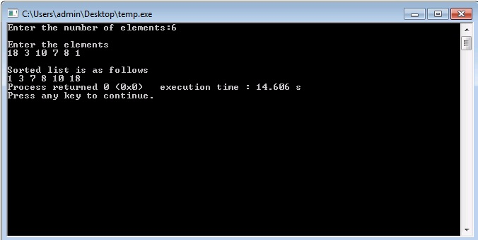

c) Insertion sorting
#include<iostream>
using namespace std;

void INSERTION_SORT(int [],int );

int main()
{
char ch;
do
{
int n;
cout<<"Enter the no. of elements in the array"<<endl;
cin>>n;
int a[n];
cout<<"Enter the elements in the array"<<endl;
for(int i=1;i<=n;i++)
{
cin>>a[i];
}
INSERTION_SORT(a,n);
cout<<"::::Sorted Output:::"<<endl;
for(int k=1;k<=n;k++)
{
cout<<a[k]<<" ";
}
cout<<endl<<"Press 'y' or 'Y' to continue!!!";
cin>>ch;
}while(ch=='y'||ch=='Y');
return 0;
}
void INSERTION_SORT(int a[],int n)
{
int key,i,j;
for(j=2;j<=n;j++)
{
key=a[j];
i=j-1;
while((i>0)&&(a[i]>key))
{
a[i+1]=a[i];
i=i-1;
}
a[i+1]=key;
}
}

Output
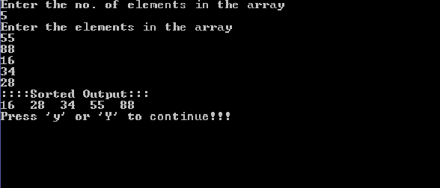

11.Write C++ programs for implementing the following sorting methods:
a)Merge sort b)Quick sort c) Heap sort d)Radix sort.
a) /* C++ Program to implement Merge Sort */
#include<iostream>
using namespace std;
void merge_sort(int [],int ,int );
void merge(int [],int,int ,int );
int main()
{
int n;
cout<<"Enter the size of the array"<<endl;
cin>>n;
int a[n];
cout<<"Enter the elements in the array"<<endl;
for(int i=1;i<=n;i++)
{
cin>>a[i];
}
cout<<"sorting using merge sort"<<endl;
int p=1,r=n;
merge_sort(a,p,r);
cout<<"sorted form"<<endl;
for(int i=1;i<=n;i++)
{
cout<<"a["<<i<<"]="<<a[i]<<endl;
}
return 0;
}
void merge_sort(int a[],int p,int r)
{
int q;
if(p<r)
{
q=(p+r)/2;
merge_sort(a,p,q);
merge_sort(a,q+1,r);
merge(a,p,q,r);
}
}
void merge(int a[],int p,int q,int r)
{
cout<<"Entered merge"<<endl;
int n1=q-p+1;
int n2=r-q;
int L[n1+1];
int R[n2+1];
for(int i=1;i<=n1;i++)
{
L[i]=a[p+i-1];
}
for(int j=1;j<=n2;j++)
{
R[j]=a[q+j];
}
L[n1+1]=999;
R[n2+1]=999;
int i=1, j=1;
for(int k=p;k<=r;k++)
{
if(L[i]<=R[j])
{
a[k]=L[i];
i=i+1;
}
else
{
a[k]=R[j];
j=j+1;
}
}
}

//Output of the above program
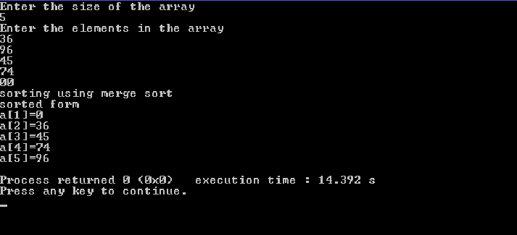

b>quick sort
#include<stdio.h>
#include<conio.h>
#include<iostream.h>
void quicksort(int a[],int lb,int ub)
{
int key=lb,i=lb,j=ub;
printf("\ni=%d j=%d key=%d\n",i,j,key);
while(i<j)
{
while(a[i]<=a[key])
i++;
while(a[j]>a[key])
j--;
if(i<j)
a[i]=((a[i]+a[j])-(a[i]=a[j]));
a[key]=((a[key]+a[j])-(a[j]=a[key]));
quicksort(a,lb,j-1);
quicksort(a,j+1,ub);
}
}
void main()
{
int i,a[30],n;
clrscr();
cout<<"enter the how many no";
cin>>n;
for(i=0;i<n;i++)
cin>>a[i];
cout<<"before elemnet\n"<<" ";
for(i=0;i<n;i++)
cout<<a[i]<<" ";
quicksort(a,0,n-1);
cout<<"\nafetr sorting"<<" ";
for(i=0;i<n;i++)
cout<<a[i]<<" ";
getch();
}

Output
enter the size of list 5
enter the elements 99
88
77
66
55
after sorting element : 55 66 77 88 99

c>heap sort
#include<stdio.h>
#include<conio.h>
#include<iostream.h>
void heapsort(int [ ],int);
void buildheap(int [ ],int);
void satisfyheap(int[ ],int,int);
void main(){
int a[10],i,s;
clrscr();
cout<<"enetr the size of list ";
cin>>s;
cout<<"enetr the elements";
for(i=0;i<s;i++){
cin>>a[i];
}
heapsort(a,s);
getch();
}
void heapsort(int a[ ],int l){
buildheap(a,l);
int h,i,temp;
h=l-1;
for(i=h;i>=0;i--){
temp=a[0];
a[0]=a[h];
a[h]=temp;
h--;
satisfyheap(a,0,h);
}
cout<<"after sorting element :";
for(i=0;i<l;i++){
cout<<"\t"<<a[i];
}
}
void buildheap(int a[ ],int l){
int i,h;
h=l-1;
for(i=(l/2);i>=0;i--){
satisfyheap(a,i,h);
}
}
void satisfyheap(int a[ ],int i,int h){
int l1,l,r,temp;
l1=2*i;
r=2*i+1;
if(l1<=h && a[l1]>a[i]){
l=l1;
}
else{
l=i;
}
if(r<=h && a[r]>a[l]){
l=r;
}
if(l!=i){
temp=a[i];
a[i]=a[l];
a[l]=temp;
satisfyheap(a,l,h);
}
}
Output
enter the size of list
5
enter the elements99
88
77
66
55
after sorting element : 55 66 77 88 99

d> radix sort
#include<stdio.h>
#include<conio.h>
#include<iostream.h>
#include<math.h>
void radixsort(int a[ ] ,int m,int n){
int temp,i,j,k,y,d,b[10],p,q;
y=-1;
for(i=1;i<=m;i++){
q=1;
y++;
p=pow(10,y);
for(j=0;j<=9;j++){
for(k=1;k<=n;k++){
d=(a[k]/p)%10;
if(d==j)
b[q++]=a[k];
}
}
for(temp=1;temp<=n;temp++)
a[temp]=b[temp];
}
}
void main(){
int i,a[30],n,max,max1;
clrscr();
cout<<"enetr tehe size";
cin>>n;
cout<<"enetr the elements ";
for(i=1;i<=n;i++)
cin>>a[i];
cout<<"before\n";
for(i=1;i<=n;i++)
cout<<a[i]<<" ";
max=0;
for(i=1;i<=n;i++)
if(a[i]>max)
max=a[i];
max1=0;
while(max!=0){
max=max/10;
max1++;
}
radixsort(a,max1,n);
cout<<"\nafter\n";
for(i=1;i<=n;i++){
cout<<a[i]<<" ";
}
getch();
}
Output
enter the size of list 5
enter the elements99
88
77
66
55
after sorting element : 55 66 77 88 99

12.Write a C++ program to perform the following operation:
a) Insertion into a B-tree
#include<stdio.h>
#include<conio.h>
#include<iostream>
using namespace std;
struct BTreeNode
{
int *data;
BTreeNode **child_ptr;
bool leaf;
int n;
}*root = NULL, *np = NULL, *x = NULL;
BTreeNode * init()
{
int i;
np = new BTreeNode;
np->data = new int[5];
np->child_ptr = new BTreeNode *[6];
np->leaf = true;
np->n = 0;
for (i = 0; i < 6; i++)
{
np->child_ptr[i] = NULL;
}
return np;
. }
void traverse(BTreeNode *p)
{
cout<<endl;
int i;
for (i = 0; i < p->n; i++)
{
if (p->leaf == false)
{
traverse(p->child_ptr[i]);
}
cout << " " << p->data[i];
}
if (p->leaf == false)
{
traverse(p->child_ptr[i]);
}
cout<<endl;
}
void sort(int *p, int n)
{
int i, j, temp;
for (i = 0; i < n; i++)
{
for (j = i; j <= n; j++)
{
if (p[i] > p[j])
{
temp = p[i];
p[i] = p[j];
p[j] = temp;
}
}
}
}
int split_child(BTreeNode *x, int i)
{
int j, mid;
BTreeNode *np1, *np3, *y;
np3 = init();
np3->leaf = true;
if (i == -1)
{
mid = x->data[2];
x->data[2] = 0;
x->n--;
np1 = init();
np1->leaf = false;
x->leaf = true;
for (j = 3; j < 5; j++)
{
np3->data[j - 3] = x->data[j];
np3->child_ptr[j - 3] = x->child_ptr[j];
np3->n++;
x->data[j] = 0;
x->n--;
}
for (j = 0; j < 6; j++)
{
x->child_ptr[j] = NULL;
}
np1->data[0] = mid;
np1->child_ptr[np1->n] = x;
np1->child_ptr[np1->n + 1] = np3;
np1->n++;
root = np1;
}
else
{
y = x->child_ptr[i];
mid = y->data[2];
y->data[2] = 0;
y->n--;
for (j = 3; j < 5; j++)
{
np3->data[j - 3] = y->data[j];
np3->n++;
y->data[j] = 0;
y->n--;
}
x->child_ptr[i + 1] = y;
x->child_ptr[i + 1] = np3;
}
return mid;
}
void insert(int a)
{
int i, temp;
x = root;
if (x == NULL)
{
root = init();
x = root;
}
else
{
if (x->leaf == true && x->n == 5)
{
temp = split_child(x, -1);
x = root;
for (i = 0; i < (x->n); i++)
{
if ((a > x->data[i]) && (a < x->data[i + 1]))
{
i++;
break;
}
else if (a < x->data[0])
{
break;
}
else
{
continue;
} }
x = x->child_ptr[i];
}
else
{
while (x->leaf == false)
{
for (i = 0; i < (x->n); i++)
{
if ((a > x->data[i]) && (a < x->data[i + 1]))
{
i++;
break;
}
else if (a < x->data[0])
{
break;
}
else
{
continue;
} }
if ((x->child_ptr[i])->n == 5)
{
temp = split_child(x, i);
x->data[x->n] = temp;
x->n++;
continue;
}
else
{
x = x->child_ptr[i];
} }
} }
x->data[x->n] = a;
sort(x->data, x->n);
x->n++;
}
int main()
{
int i, n, t;
cout<<"enter the no of elements to be inserted\n";
cin>>n;
for(i = 0; i < n; i++)
{
cout<<"enter the element\n";
cin>>t;
insert(t);
}
cout<<"traversal of constructed tree\n";
traverse(root);
getch();
}
Output
enter the no of elements to be inserted
8
enter the element
10
enter the element
20
enter the element
5
enter the element
6
enter the element
12
enter the element
30
enter the element
7
enter the element
17
traversal of constructed tree
5 6 7
10
12 17 20 30
13.Write a C++ program to implement all the functions of a dictionary (ADT) using hashing.
#include<iostream>
#include<conio.h>
#include<stdlib.h>
using namespace std;
# define max 10
typedef struct list
{
int data;
struct list *next;
}node_type;
node_type *ptr[max],*root[max],*temp[max];
class Dictionary
{
public:
int index;
Dictionary();
void insert(int);
void search(int);
void delete_ele(int);
};
Dictionary::Dictionary()
{
index=-1;
for(int i=0;i<max;i++)
{
root[i]=NULL;
ptr[i]=NULL;
temp[i]=NULL;
}
}
void Dictionary::insert(int key)
{
index=int(key%max);
ptr[index]=(node_type*)malloc(sizeof(node_type));
ptr[index]->data=key;
if(root[index]==NULL)
{
root[index]=ptr[index];
root[index]->next=NULL;
temp[index]=ptr[index];
}
else
{
temp[index]=root[index];
while(temp[index]->next!=NULL)
temp[index]=temp[index]->next;
temp[index]->next=ptr[index];
}
}
void Dictionary::search(int key)
{
int flag=0;
index=int(key%max);
temp[index]=root[index];
while(temp[index]!=NULL)
{
if(temp[index]->data==key)
{
cout<<"\nSearch key is found!!";
flag=1;
break;
}
else temp[index]=temp[index]->next;
}
if (flag==0)
cout<<"\nsearch key not found.......";
}
void Dictionary::delete_ele(int key)
{
index=int(key%max);
temp[index]=root[index];
while(temp[index]->data!=key && temp[index]!=NULL)
{
ptr[index]=temp[index];
temp[index]=temp[index]->next;
}
ptr[index]->next=temp[index]->next;
cout<<"\n"<<temp[index]->data<<" has been deleted.";
temp[index]->data=-1;
temp[index]=NULL;
free(temp[index]);
}
main()
{
int val,ch,n,num;
char c;
Dictionary d;
do
{
cout<<"\nMENU:\n1.Create";
cout<<"\n2.Search for a value\n3.Delete an value";
cout<<"\nEnter your choice:";
cin>>ch;
switch(ch)
{
case 1:cout<<"\nEnter the number of elements to be inserted:";
cin>>n;
cout<<"\nEnter the elements to be inserted:";
for(int i=0;i<n;i++)
{
cin>>num;
d.insert(num);
}
break;
case 2:cout<<"\nEnter the element to be searched:";
cin>>n;
d.search(n);
case 3:cout<<"\nEnter the element to be deleted:";
cin>>n;
d.delete_ele(n);
break;
default:cout<<"\nInvalid choice....";
}
cout<<"\nEnter y to continue......";
cin>>c;
}while(c=='y');
getch();
}
Output
1.Create
2.Search for a value
3.Delete an value
Enter your choice:1
Enter the number of elements to be inserted:8
Enter the elements to be inserted:10 4 5 8 7 12 6 1
Enter y to continue……y
MENU:
1.Create
2.Search for a value
3.Delete an value
Enter your choice:2
Enter the element to be searched:12
Search key is found!!
Enter the element to be deleted:1
1 has been deleted.
Enter y to continue……y
14.Write a C++ program for implementing Knuth-Morris- Pratt pattern matching algorithm.
#include<iostream.h>
#include<stdio.h>
#include<string.h>
#include<stdlib.h>
void computeLPSArray(char *pat, int M, int *lps);
void KMPSearch(char *pat, char *txt)
{
int M = strlen(pat);
int N = strlen(txt);
// create lps[] that will hold the longest prefix suffix values for pattern
int *lps = (int *)malloc(sizeof(int)*M);
int j = 0; // index for pat[]

// Preprocess the pattern (calculate lps[] array)
computeLPSArray(pat, M, lps);
int i = 0; // index for txt[]
while(i < N)
{
if(pat[j] == txt[i])
{
j++;
i++;
}
if (j == M)
{
Cout<<"Found pattern at index %d \n"<< i-j;
j = lps[j-1];
}
else if(pat[j] != txt[i])
{
if(j != 0)
j = lps[j-1];
else
i = i+1;
}
}
free(lps);
}
void computeLPSArray(char *pat, int M, int *lps)
{
int len = 0; // lenght of the previous longest prefix suffix
int i;
lps[0] = 0; // lps[0] is always 0
i = 1;
// the loop calculates lps[i] for i = 1 to M-1
while(i < M)
{
if(pat[i] == pat[len])
{
len++;
lps[i] = len;
i++;
}
else // (pat[i] != pat[len])
{
if( len != 0 )
{
// This is tricky. Consider the example AAACAAAA and i = 7.
len = lps[len-1];
// Also, note that we do not increment i here
}
else // if (len == 0)
{
lps[i] = 0;
i++;
}
}
}
}
// Driver program to test above function
int main()
{
char *txt = "ABABDABACDABABCABAB";
char *pat = "ABABCABAB";
KMPSearch(pat, txt);
return 0;
}
Output
Found pattern at index 10

15.Write C++ programs that use non-recursive functions to traverse the given
binary tree in
a) Preorder b) inorder and c) postorder.
#include<iostream>
#include<conio.h>
#include<stdlib.h>
using namespace std;
class node
{
public:
class node *left;
class node *right;
int data;
};
class tree: public node
{
public:
int stk[50],top;
node *root;
tree()
{
root=NULL;
top=0;
}
void insert(int ch)
{
node *temp,*temp1;
if(root== NULL)
{
root=new node;
root->data=ch;
root->left=NULL;
root->right=NULL;
return;
}
temp1=new node;
temp1->data=ch;
temp1->right=temp1->left=NULL;
temp=search(root,ch);
if(temp->data>ch)
temp->left=temp1;
else
temp->right=temp1;
}
node *search(node *temp,int ch)
{
if(root== NULL)
{
cout <<"no node present";
return NULL;
}
if(temp->left==NULL && temp->right== NULL)
return temp;

if(temp->data>ch)
{ if(temp->left==NULL) return temp;
search(temp->left,ch);}
else
{ if(temp->right==NULL) return temp;
search(temp->right,ch);
} }
void display(node *temp)
{
if(temp==NULL)
return ;
display(temp->left);
cout<<temp->data;
display(temp->right);
}
void inorder( node *root)
{
node *p;
p=root;
top=0;
do
{
while(p!=NULL)
{
stk[top]=p->data;
top++;
p=p->left;
}
if(top>0)
{
p=pop(root);
cout << p->data;
p=p->right;
}
}while(top!=0 || p!=NULL);
}
node * pop(node *p)
{
int ch;
ch=stk[top-1];
if(p->data==ch)
{
top--;
return p;
}
if(p->data>ch)
pop(p->left);
else
pop(p->right);
}
};
main()
{
tree t1;
int ch,n,i;
while(1)
{
cout <<"\n1.INSERT\n2.DISPLAY 3.INORDER TRAVERSE\n4.EXIT\nEnter your choice:";
cin >> ch;
switch(ch)
{
case 1: cout <<"enter no of elements to insert:";
cin >> n;
for(i=1;i<=n;i++)
{ cin >> ch;
t1.insert(ch);
}
break;
case 2: t1.display(t1.root);break;
case 3: t1.inorder(t1.root); break;
case 4: exit(1);
}
}
}
OUTPUT
1.INSERT
2.DISPLAY 3.INORDER TRAVERSE
4.EXIT
Enter your choice:1
enter no of elements to inser
5 24 36 11 44 2 21
1.INSERT
2.DISPLAY 3.INORDER TRAVERSE
4.EXIT
Enter your choice:3
251121243644
1.INSERT
2.DISPLAY 3.INORDER TRAVERSE
4.EXIT
Enter your choice:3
251121243644
1.INSERT
2.DISPLAY 3.INORDER TRAVERSE
4.EXIT
Enter your choice:4

16. Write C++ programs for the depth first and breadth first traversals of a graph.
BFS search:-
#include<iostream>
#include<conio.h>
#include<stdlib.h>
using namespace std;
int cost[10][10],i,j,k,n,qu[10],front,rare,v,visit[10],visited[10];
main()
{
int m;
cout <<"enterno of vertices";
cin >> n;
cout <<"ente no of edges";
cin >> m;
cout <<"\nEDGES \n";
for(k=1;k<=m;k++)
{
cin >>i>>j;
cost[i][j]=1;
}
cout <<"enter initial vertex";
cin >>v;
cout <<"Visitied vertices\n";
cout << v;
visited[v]=1;
k=1;
while(k<n)
{
for(j=1;j<=n;j++)
if(cost[v][j]!=0 && visited[j]!=1 && visit[j]!=1)
{
visit[j]=1;
qu[rare++]=j;
}
v=qu[front++];
cout<<v << " ";
k++;
visit[v]=0; visited[v]=1;
}
}
Output
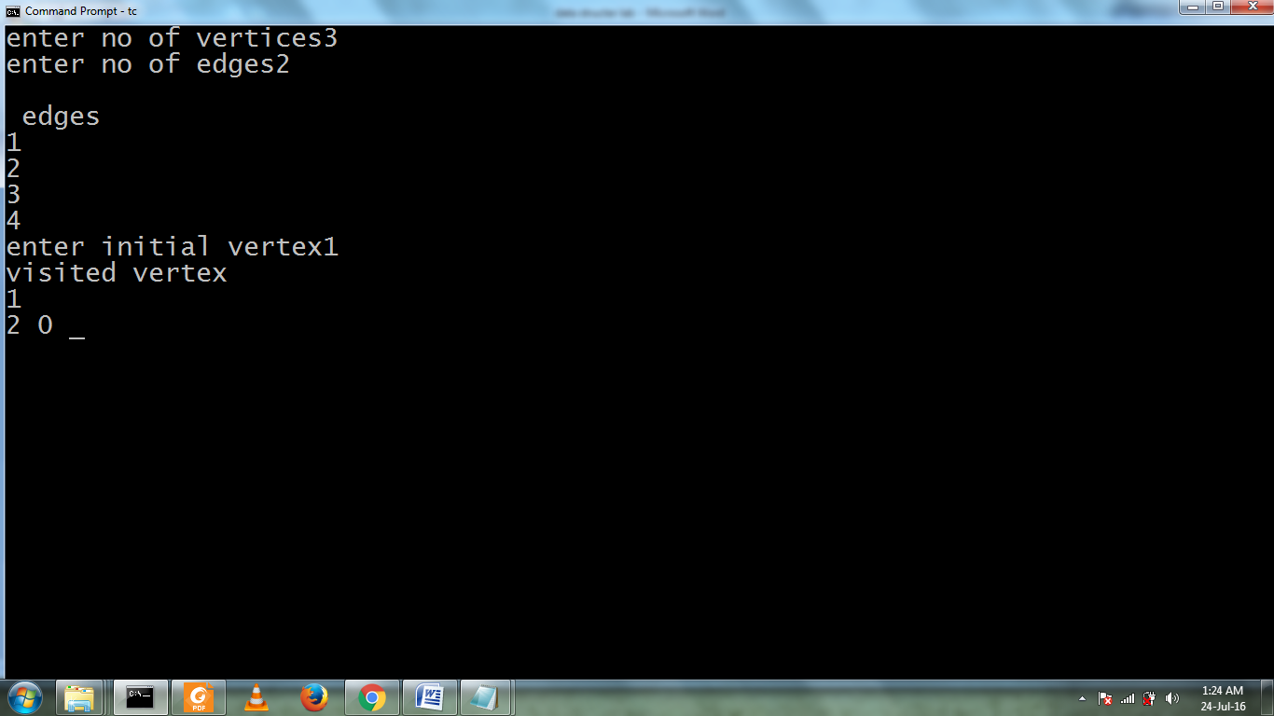

.DFS program
#include<iostream.h>
#include<conio.h>
#define max 5
void depth_first_search(int adj[][max],int visited [ ],int start)
{
int stack[max];
int top=-1,i;
printf("%c",start+65);
visited[start]=1;
stack[++top]=start;
while(top!=-1)
{
start=stack[top];
for(i=0;i<max;i++)
{
if(adj[start][i]&& visited[i]==0)
{
stack[++top]=i;
printf("%c-",i+65);
visited[i]=1;
break;
}
}
if(i==max)
top--;
}
}
void main(){
int adj[max][max];
int visited[max]={0},i,j;
printf("\n enter the adjancency matrix :");
for(i=0;i<max;i++)
for(j=0;j<max;j++)
scanf("%d",&adj[i][j]);
printf("DFS Traversal");
depth_first_search(adj,visited,0);
printf("\n");
getch();
}

OUTPUT:-
enter the adjacency matrix
0 1 0 1 0
1 0 1 1 0
0 1 0 0 1
1 1 0 0 1
0 0 1 1 0
DFS traversal :A-> C-> E->

